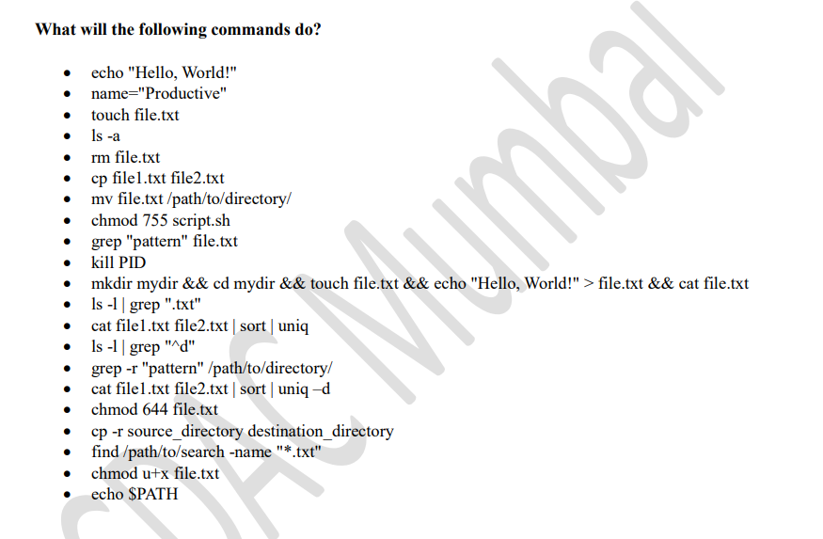

echo is to print the text in CLI



Touch is use to create file & ls -a is to list all the file and hidden file present in the directory

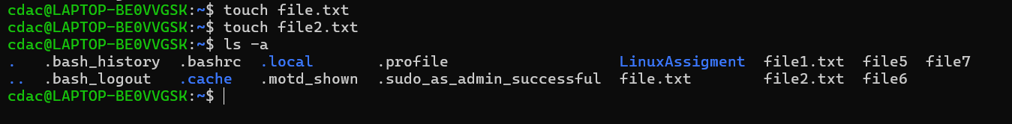

Rm is used to remove the file from current directory

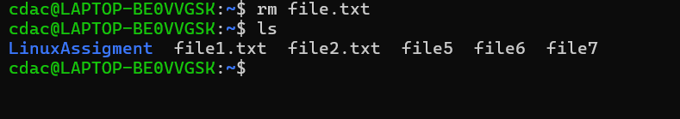

Cp command is use to copy the content from file1 to file2   
even file2 is now present it will create the file and paste the content in it.

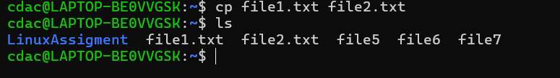

Mv cmd is used to move the file to the destination path

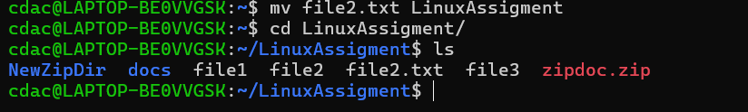

Chmod is use to give permission to owner, group present in the computer system and the other user who is outside from you present network

0 no permission

1 give execute permission

2 give write permission

3 give write and execute permission

4 give read permission

5 give read and execute permission

6 give read write

7 give all permission

In below screenshot before using chmod cmd the user have read & write permission,

Group & other user where having only read permission  
after chmod cmd exceuted the owner wall given all permission, the group and other user where given read and execute cmd

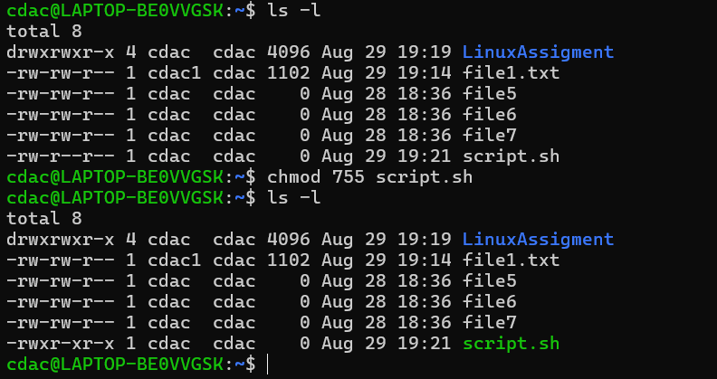

grep "ornament" file1.txt :: is use to search the word ornament word in file1.txt

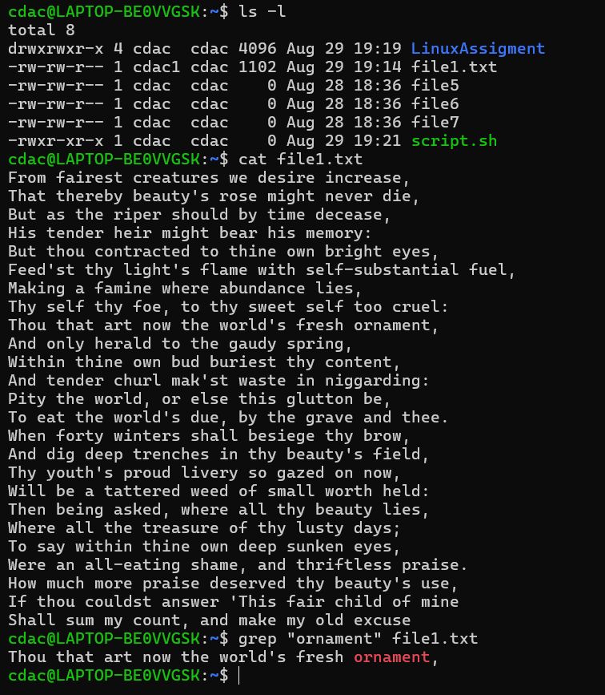

kill PID  
kill pid is use to kill the existing process present in system

mkdir mydir && cd mydir && touch file.txt && echo "Hello, World!" > file.txt && cat file.txt  
as we are using AND operator we are going from left to right side  
mkdir mydir :: use to create the directory mydir in current folder

cd mydir :: ch cmd is use to move backword and forward into the path, here we enter into mydir directory  
touch file.txt :: the touch cmd is use to create new file in present directory  
echo "Hello, World!" :: echo cmd is use to print the argument provided in double quotes

>: redirection operator is use to store the output from first cmd into the file of second cmd here hello word is the output of echo cmd and it is stored into the file.txt present in mydir directory

Cat file.txt :: is use to list the content present in the given file  
output is given below



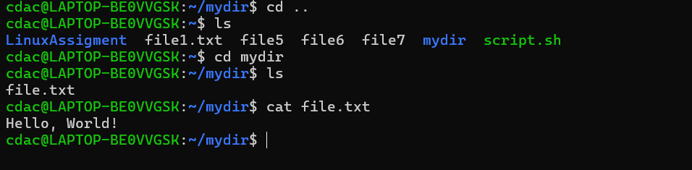  
  
ls -l | grep ".txt"  
ls -l cmd : is use to check detail view of the file like permission provided to owner, group, other users

Owner of the file(cdac1) & which group the file belongs, also give idea about the file size along with when the file is created   
 | pipe operator output generated my ls -l cmd is given to grep cmd

Grep “.txt” ::is use to search the file with .txt extension

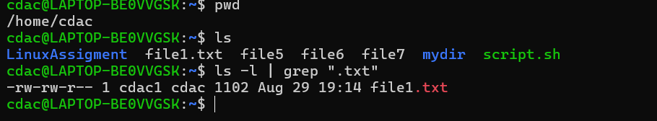

Echo $PATH is use to print/list all the path stored in path variable of current system



chmod u+x file.txt  
the chmod cmd is use to give permission, u is for owner and x is for executable , so overall we provided the owner the permission for executable the file3  
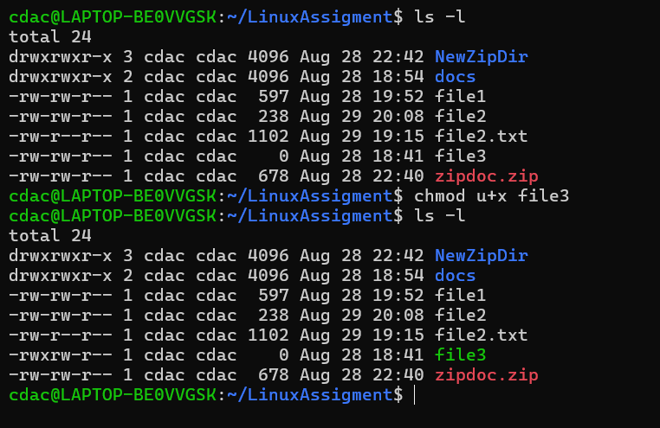

chmod 644 file2.txt  
the chmod is give execute, read & write access to the mentioned file  
6 is for read and write

4 is for read only

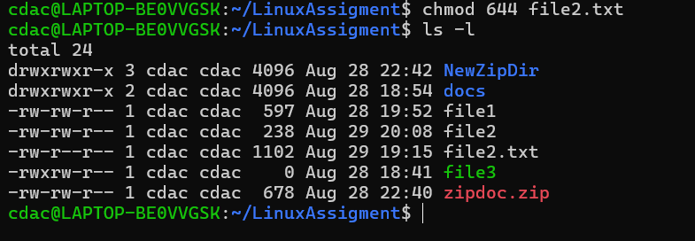

Find cmd is use to search and locate the file



ls -l | grep "^d"

ls -l cmd : is use to check detail view of the file like permission provided to owner, group, other users

Owner of the file(cdac1) & which group the file belongs, also give idea about the file size along with when the file is created

| pipe

grep “^d”:: it is use to search the directory present in current directory (if we remove ^ then it will highlight the word d from ls -l ouput)  
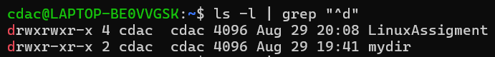

cat file1.txt file2.txt | sort | uniq

• grep -r "pattern" /path/to/directory/

• cat file1.txt file2.txt | sort | uniq –d

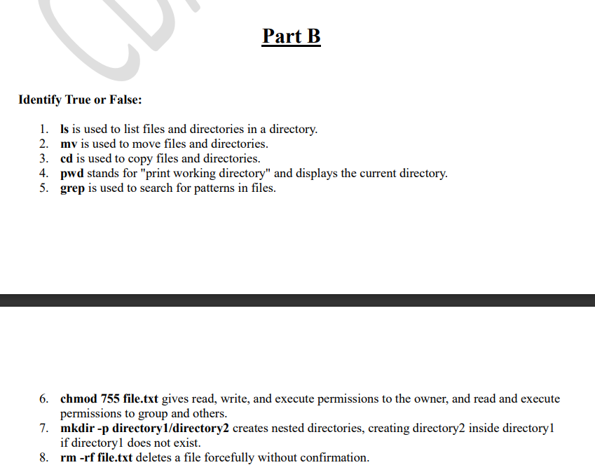

1)True

2)True

3)False

4)true

5)true

6)true

7)True

8)TRUE

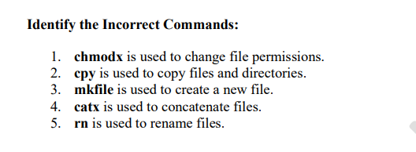

1,2,3,4 are the incorrect statement

